Lab - DC Circuits:
https://phet.colorado.edu/sims/html/circuit-construction-kit-dc/latest/circuit-construction-kit-dc_en.html

Step I: Simple Circuit (Single Battery)
Create a simple circuit with one battery (1.5V), one light bulb, a switch and two wires.
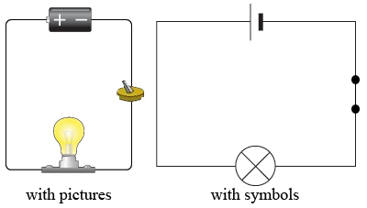
- To adjust the voltage on the battery simply click on the battery itself and a slider should appear that lets you adjust the voltage
- Use the meter to measure the voltage drop across the bulb (Place one end of the meter probe at one contact point and the other probe at the other contact point. Contact point is where the wire is touching the bulb. V = _____________

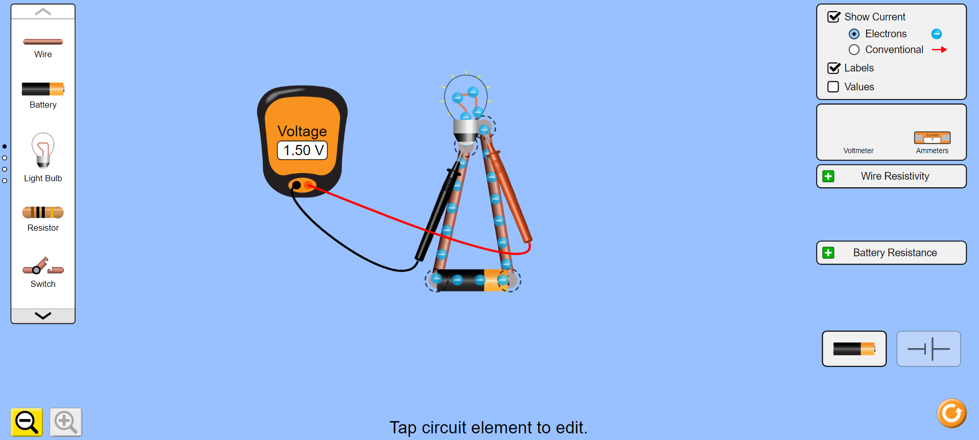

- Connect the meter so you can measure the current through the bulb. Disconnect one contact point from the bulb and connect the meter from the disconnected point to the bulb to measure the current. I = _____________

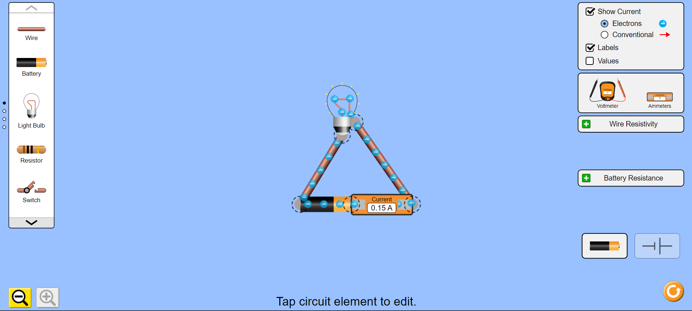

Step II: Simple Circuit (Two Batteries)
- Add one more battery. Make sure to connect the positive end to the negative end of each cells. This is called a series connection for the batteries.
- How does this affect the brightness of the bulb?
- Connect the meters as in the previous step and record the voltage and the current.

V = _____________ I = _____________

Step III: Series Circuit - A series circuit has only one path for current to flow
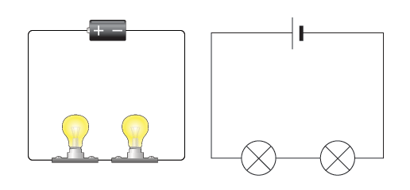
- Create a series circuit connecting a single battery (1.5V) and two light bulbs.
- Observe the brightness and record the voltage across each bulb and the current through the circuit.
V₁ = _____________ V₂ = _____________
I₁ = _____________ I₂ = _____________

- Now add a third bulb and observe how the brightness of each bulb is affected. Describe your observation.

_____________________________________________________________

Step IV: Parallel Circuit (Single Cell)
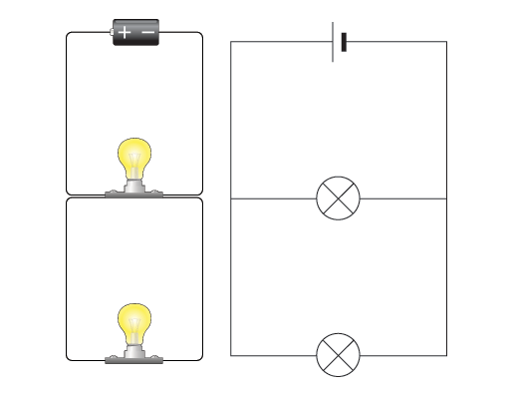
Create a parallel circuit (two bulbs one battery)
- What is the difference in the brightness of the bulbs between the series and parallel circuits? Why do you think this difference exists? Measure the voltage across each bulb and the current through each bulb and record your values.
V₁ = _____________ V₂ = _____________
I₁ = _____________ I₂ = ______________

